1. **Identify 3 competitors**
   * 1. <https://asoftmurmur.com/>
        1. Direct Competitor - This website functions as a simple to use soundboard/whitenoise website for helping users relax. Users can listen to, create, and save custom mixes of ambient/relaxing sounds. There is also documentation provided to the user to help them learn more about different techniques to reduce stress.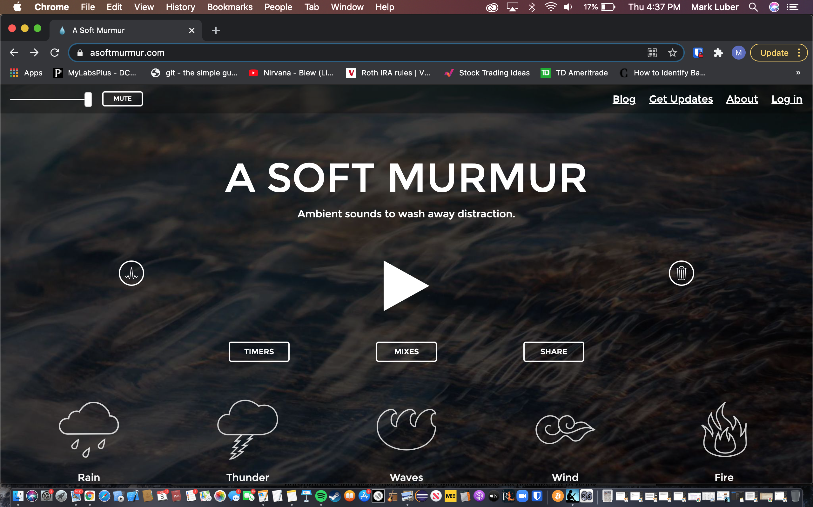
     2. <https://xhalr.com/>
        1. Indirect Competitor - This website is an interactive and customizable app that helps users learn breathing techniques. The main purpose of this website is to help reduce stress, anxiety, and to use in meditation. However, this website does not include a way for users to listen to different ambient/nature/relaxing sounds. This website is mainly focused on teaching users how to practice different breathing techniques.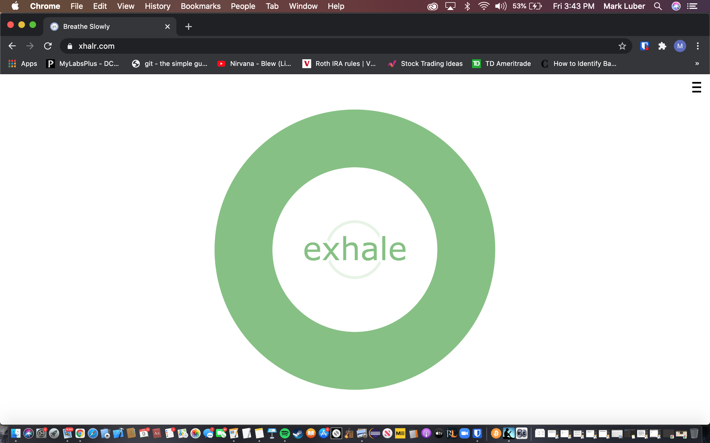
     3. <https://quietkit.com/>
        1. Direct Competitor - This website provides users with a comprehensive guide for beginners to learn meditation techniques. It also offers the user a good selection of different audio-guided meditations to follow along to. Additionally, quietkit also provides unguided meditations which are basically just ambient/nature/meditation sounds. I think its interesting to note that It also provides school teachers free information on how to teach meditation to a class.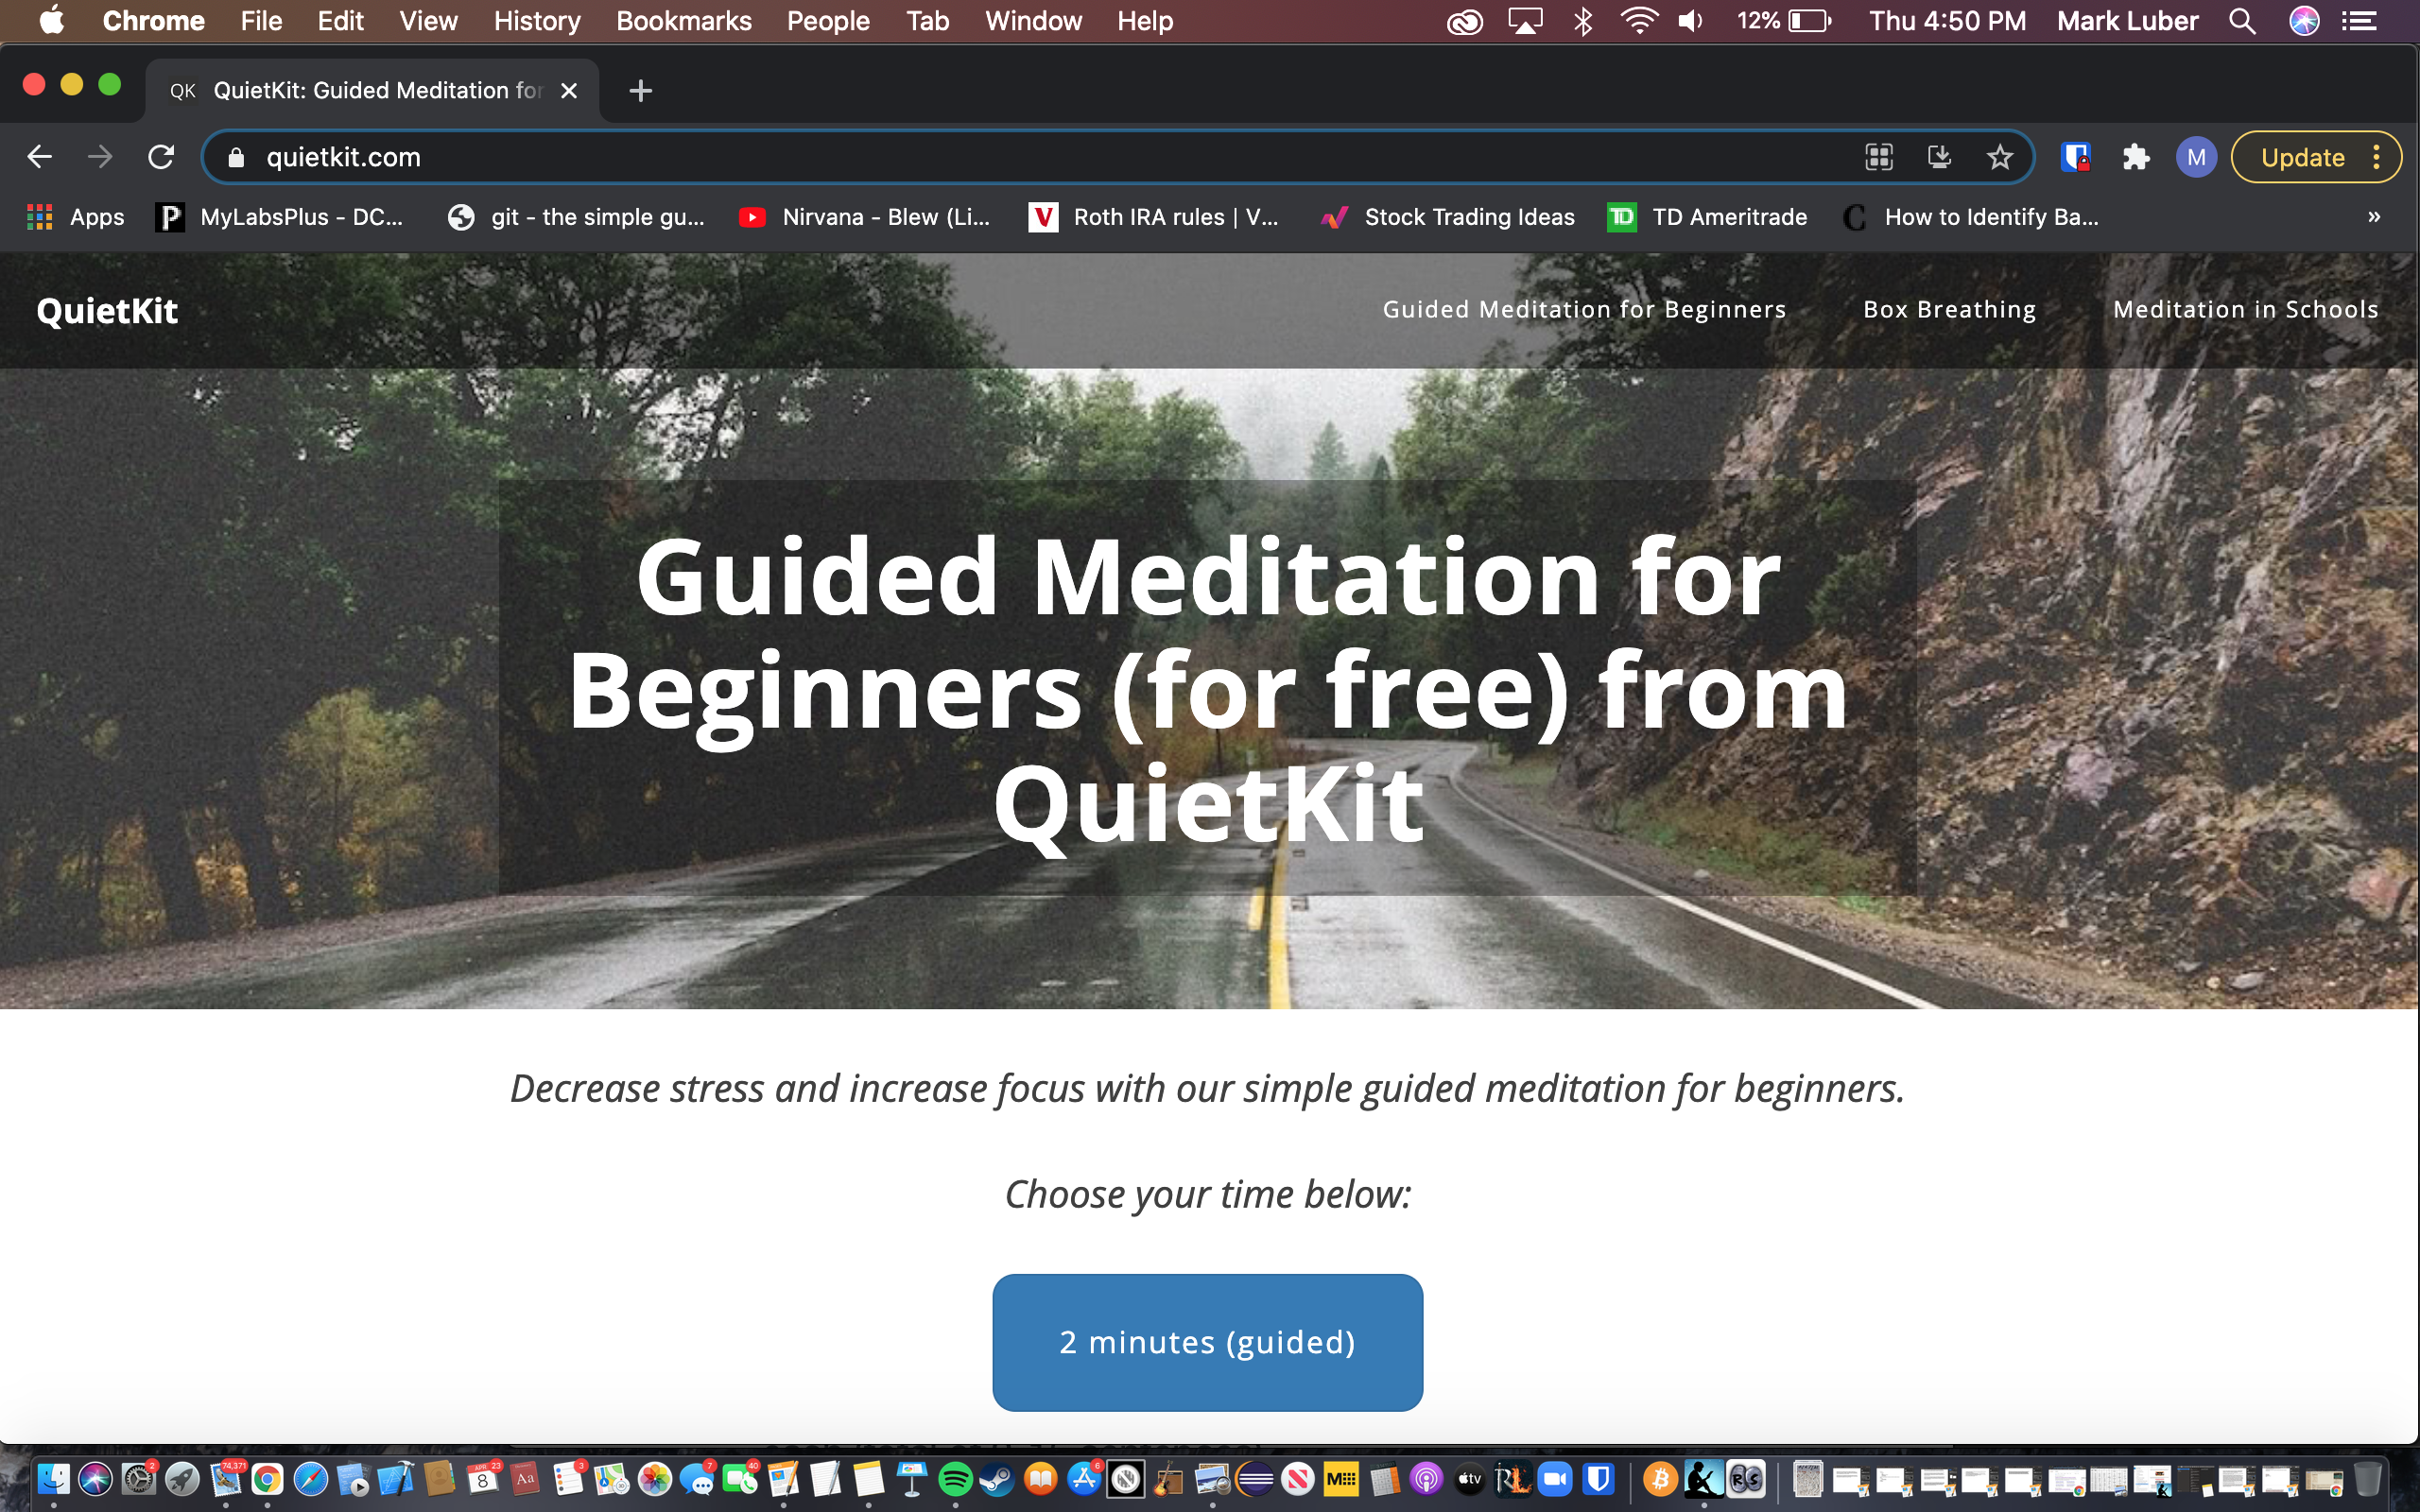

**2. Content and Navigation**

* 1. <https://asoftmurmur.com/>
     + 1. The menu is located at the top of the webpage in the form of a horizontal navbar. There are four sections grouped to the top right of the website along with a volume slider and mute button on the top left. The volume slider is nice because it allows the user to easily customize the volume of the sound currently playing. The four sections to the right are the main components of the nav bar. The issue I see with the appearance of the navbar is that it’s not visually consistent throughout the whole website.
  2. <https://xhalr.com/>
     + 1. The menu is simply accessed by clicking the menu icon the top right corner of the website. There is no option for the user but to click the menu button as it is the only button available on the entire website. I like how the main content of the menu is hidden until the user clicks the menu icon. It gives the website a cleaner, more sleek look. When the user clicks the main menu icon, the menu slides into view. Within the menu the user can access the customization features, edit themes and variables, donate, and access additional information. There is also an embed code provided so users can integrate this app into their own website. I like the idea of having an embed code, it could be an effective way to gain more exposure for your website or app. Within the menu users can also toggle audio and text and enter fullscreen mode.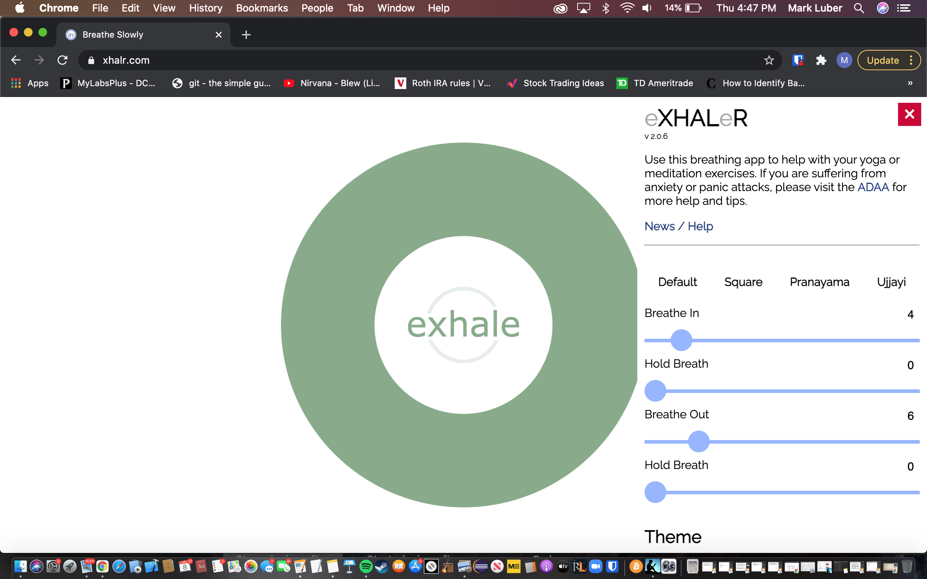

**Menu Icon**

**Full Menu when opened:**

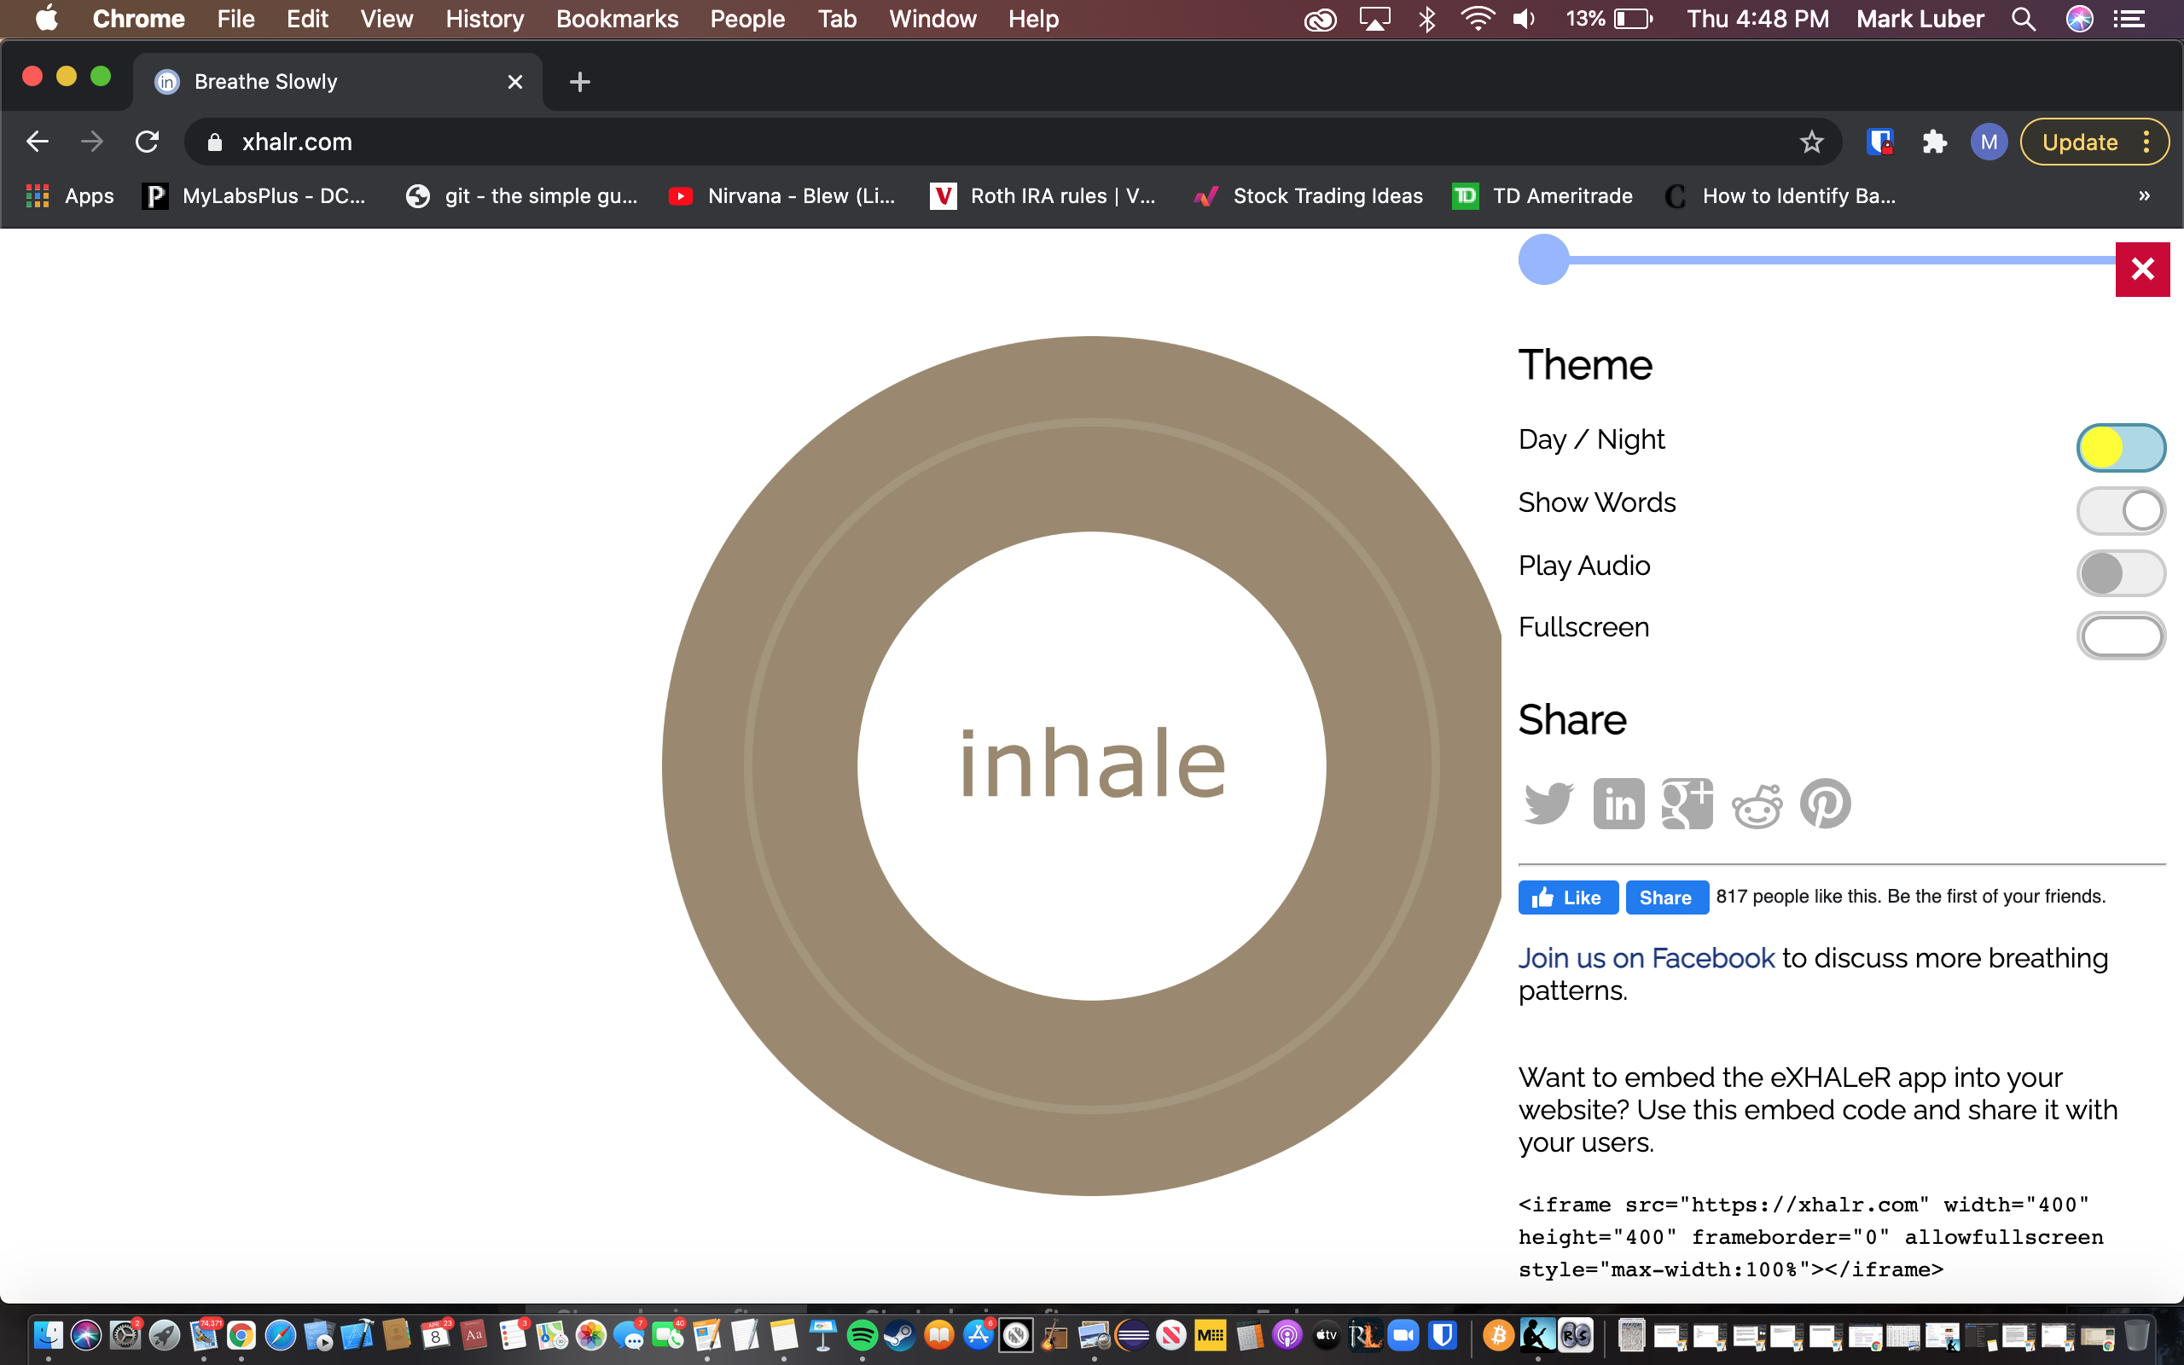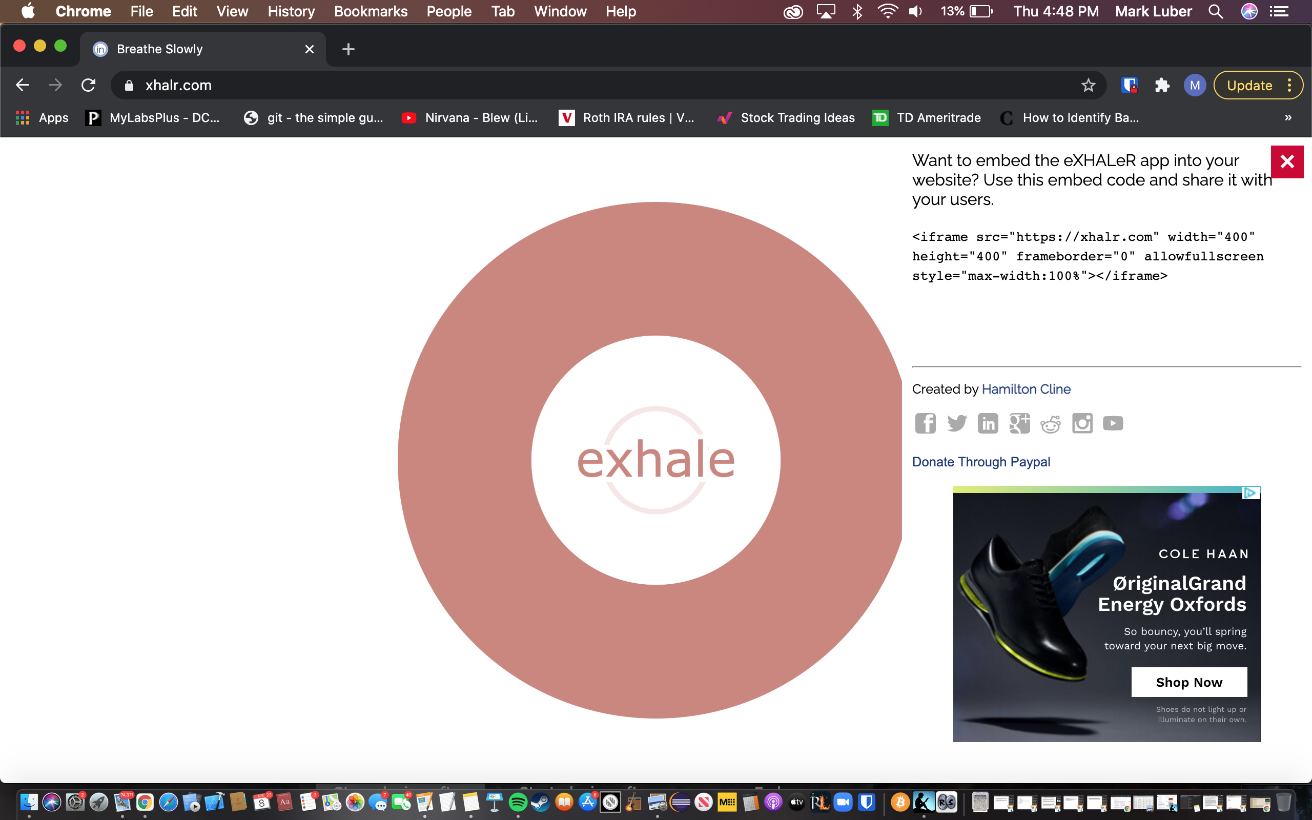

* 1. <https://quietkit.com/>
     + 1. The menu is presented to the user at the top of the webpage as a horizontal navbar. There are basically 3 options to choose from, the homepage (where most of the information exists), a section for practicing breathing techniques, and a section providing information on teaching meditation techniques in schools. The menu is simple yet effective. I would potentially have made the main navbar a solid color and not transparent. The reason for this is that the nav bar text would probably be more legible if the background was a solid color. Also, the text is slightly small compared to the rest of the text on the website and could be hard for some users to see.
  2. Best menu ranked best to worst
     + 1. xhalr.com - I like this menu the best because it is the most visually appealing. The menu is very visually appealing because the graphics look clean and minimalistic yet professional. I like how the main menu comes into view via a smooth animation. In terms of functionality this menu is easy to navigate and use, yet provides the most customization to the user. The developer did a great job creating this menu. Additionally, I think this menu is the best because all the information that the user needs is available all in one place.
       2. aquietkit.com - The design of this menu is very simplistic and very straightforward. It provides just 3 nav bar elements for the user to choose from. It is nothing elaborate, but it is consistent, straightforward and to the point.
       3. asoftmurmur.com - Even though this menu is simple and easy to read; I would say this is the worst menu because it does not visually look the same throughout all the different pages of the website. It is inconsistent. These inconsistencies can throw the entire look of the website off. This small design error also can impair the functionality of the website. For example, on the “about page” there is no menu at all. This leaves the user with no way to navigate back to the home page. Additionally, on the “blog” page the navbar is missing 2 nav bar elements.

**3. Aesthetics and Style**

* 1. <https://asoftmurmur.com/>
     + 1. The imagery and colors are done quite well. The developer mainly used white, black, and grey colors. A picture of moving water is visible through the transparent background. This website also scales nicely and responds well to resizing. The icons are well done and very visually pleasing and it is very clear which each icon does. All the icons, buttons, and text are white and the background, header, and navbar items are black and grey. The contrast is nice. I think the imagery and colors are implemented really well.
  2. <https://xhalr.com/>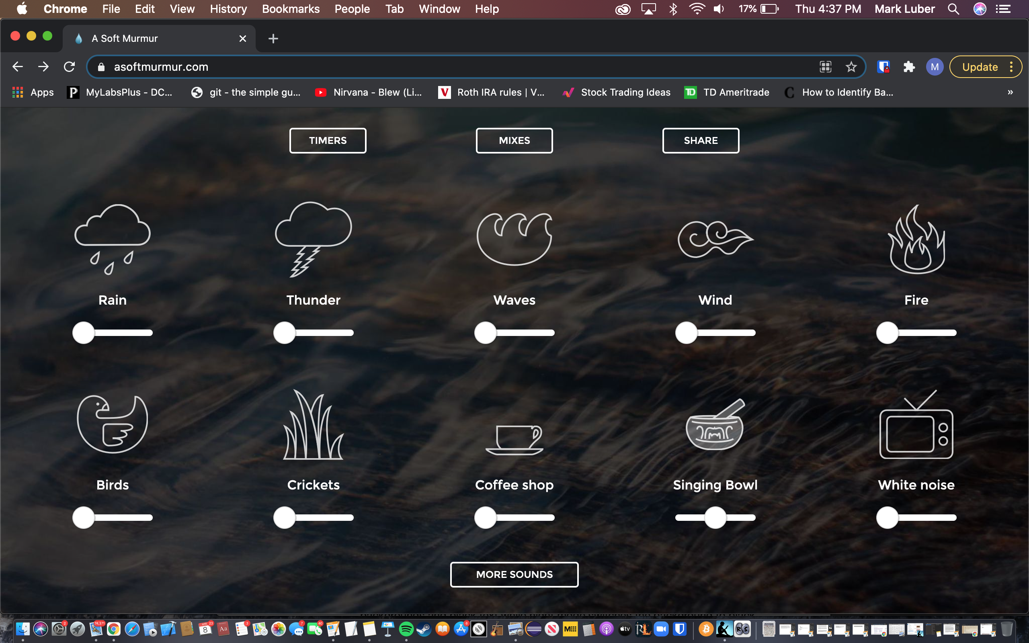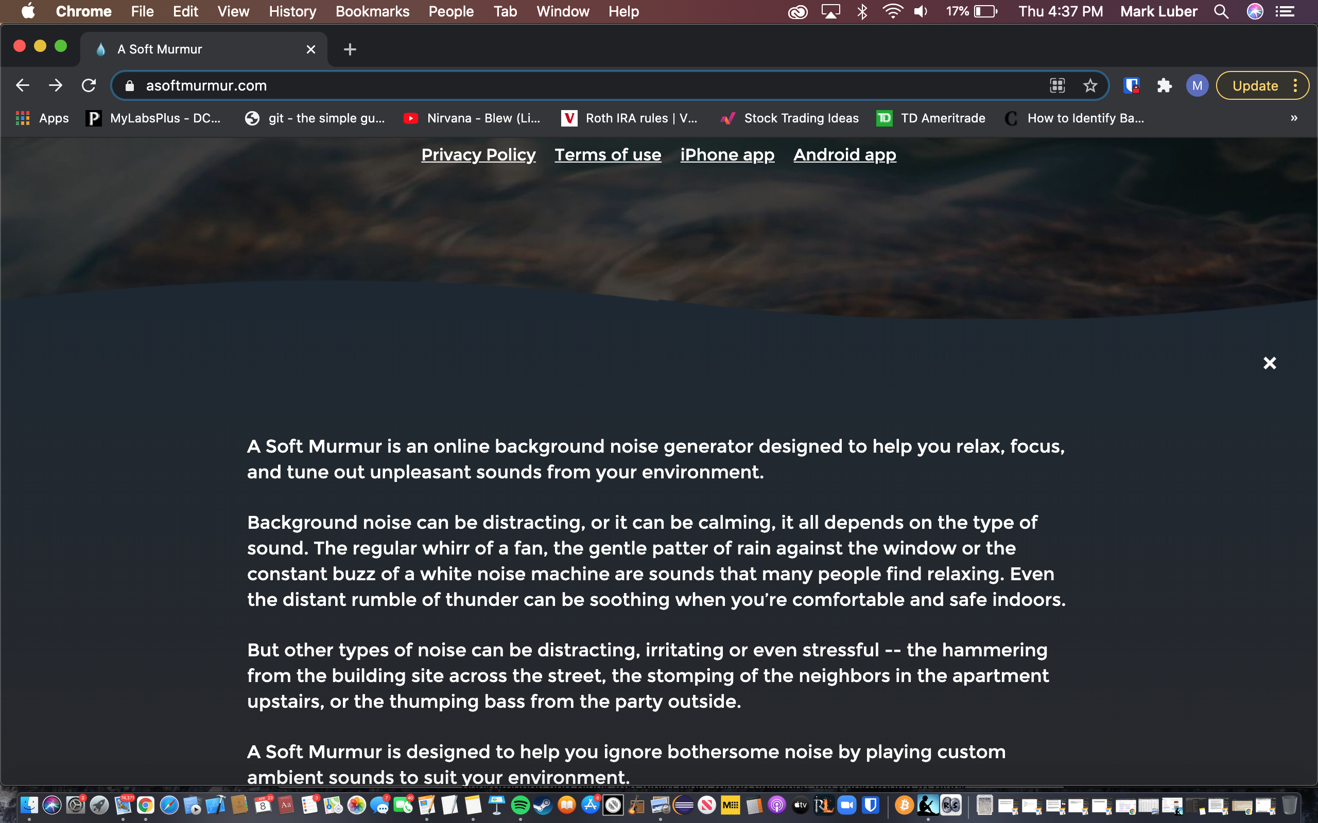

**Sound Icons**

**Audio player buttons**

**Documentation**

* + - 1. The colors and imagery used are done really well. The website has a very professional yet minimalistic look. The overall theme can be changed through a toggle button on the main menu from day/night mode. The feature to switch the website into night or day mode allows the user even more customization/control based upon what is more visually pleasing. Day mode switches the overall theme to white backgrounds and black text while night mode switches the background to black and the text white. This is a great feature that gives the user the ability to change the appearance of the website to be easier on the eyes. The developer uses color in a clever way. I like how the color of the main circle located the center of the website gradually changes over time. It not only grabs the users attention, but also adds to the overall theme of the website. I think is a really cool feature and it works well in this scenario.

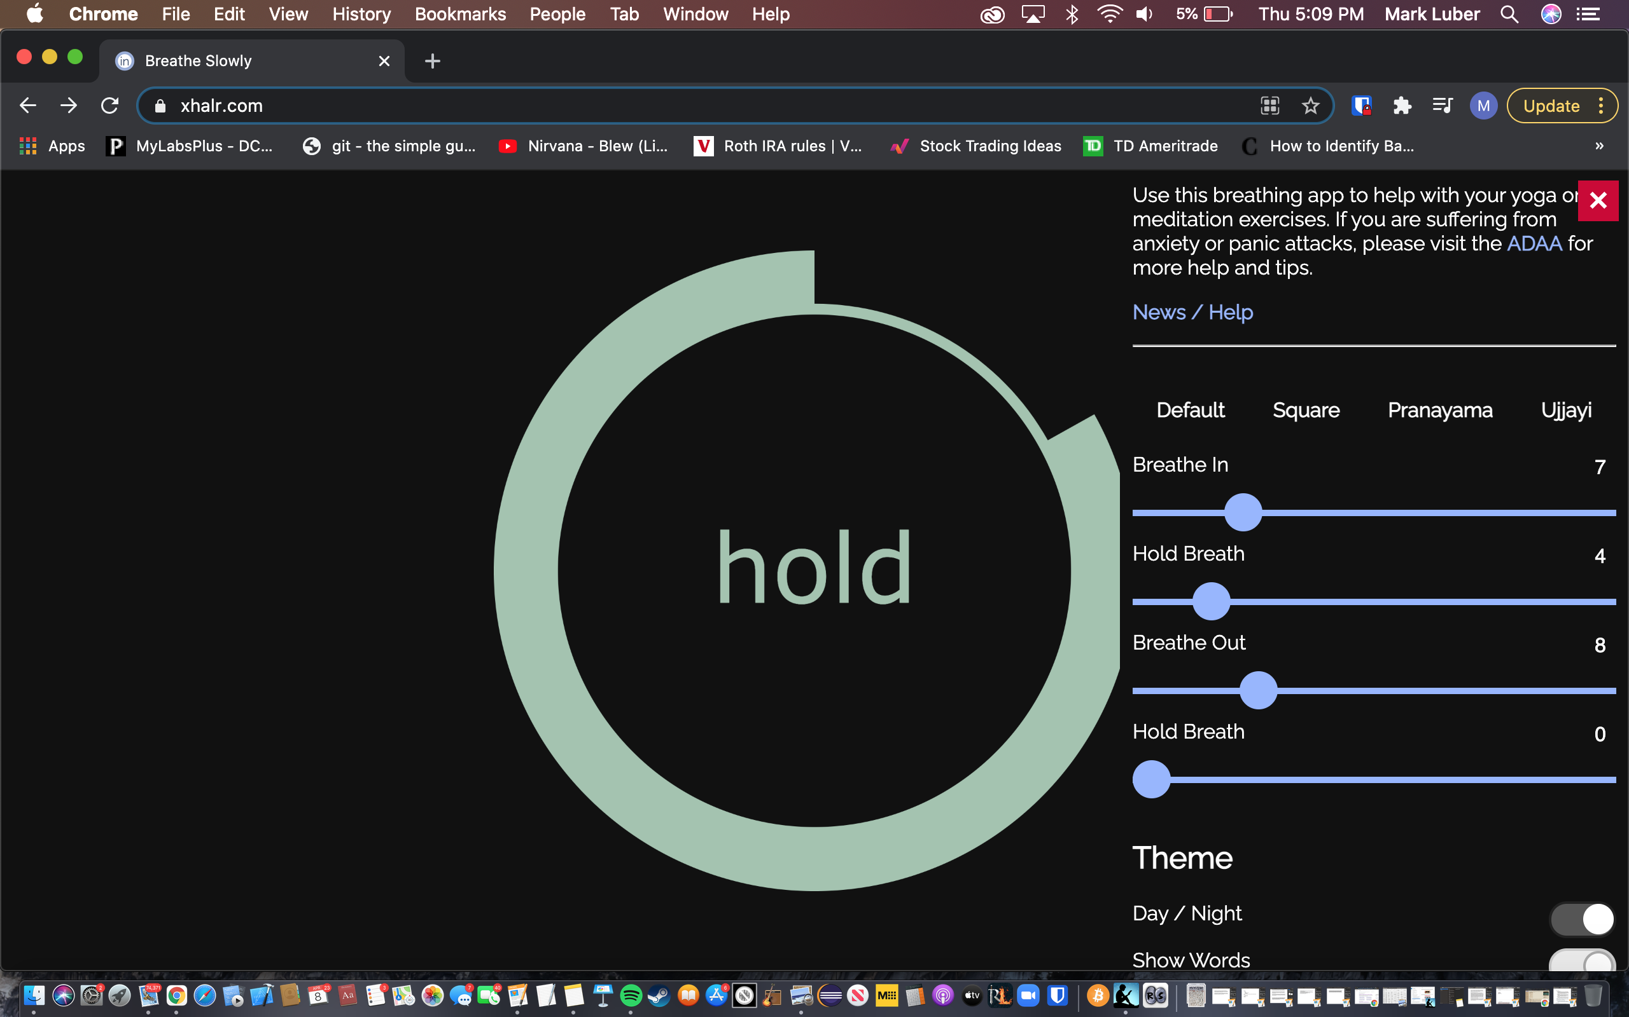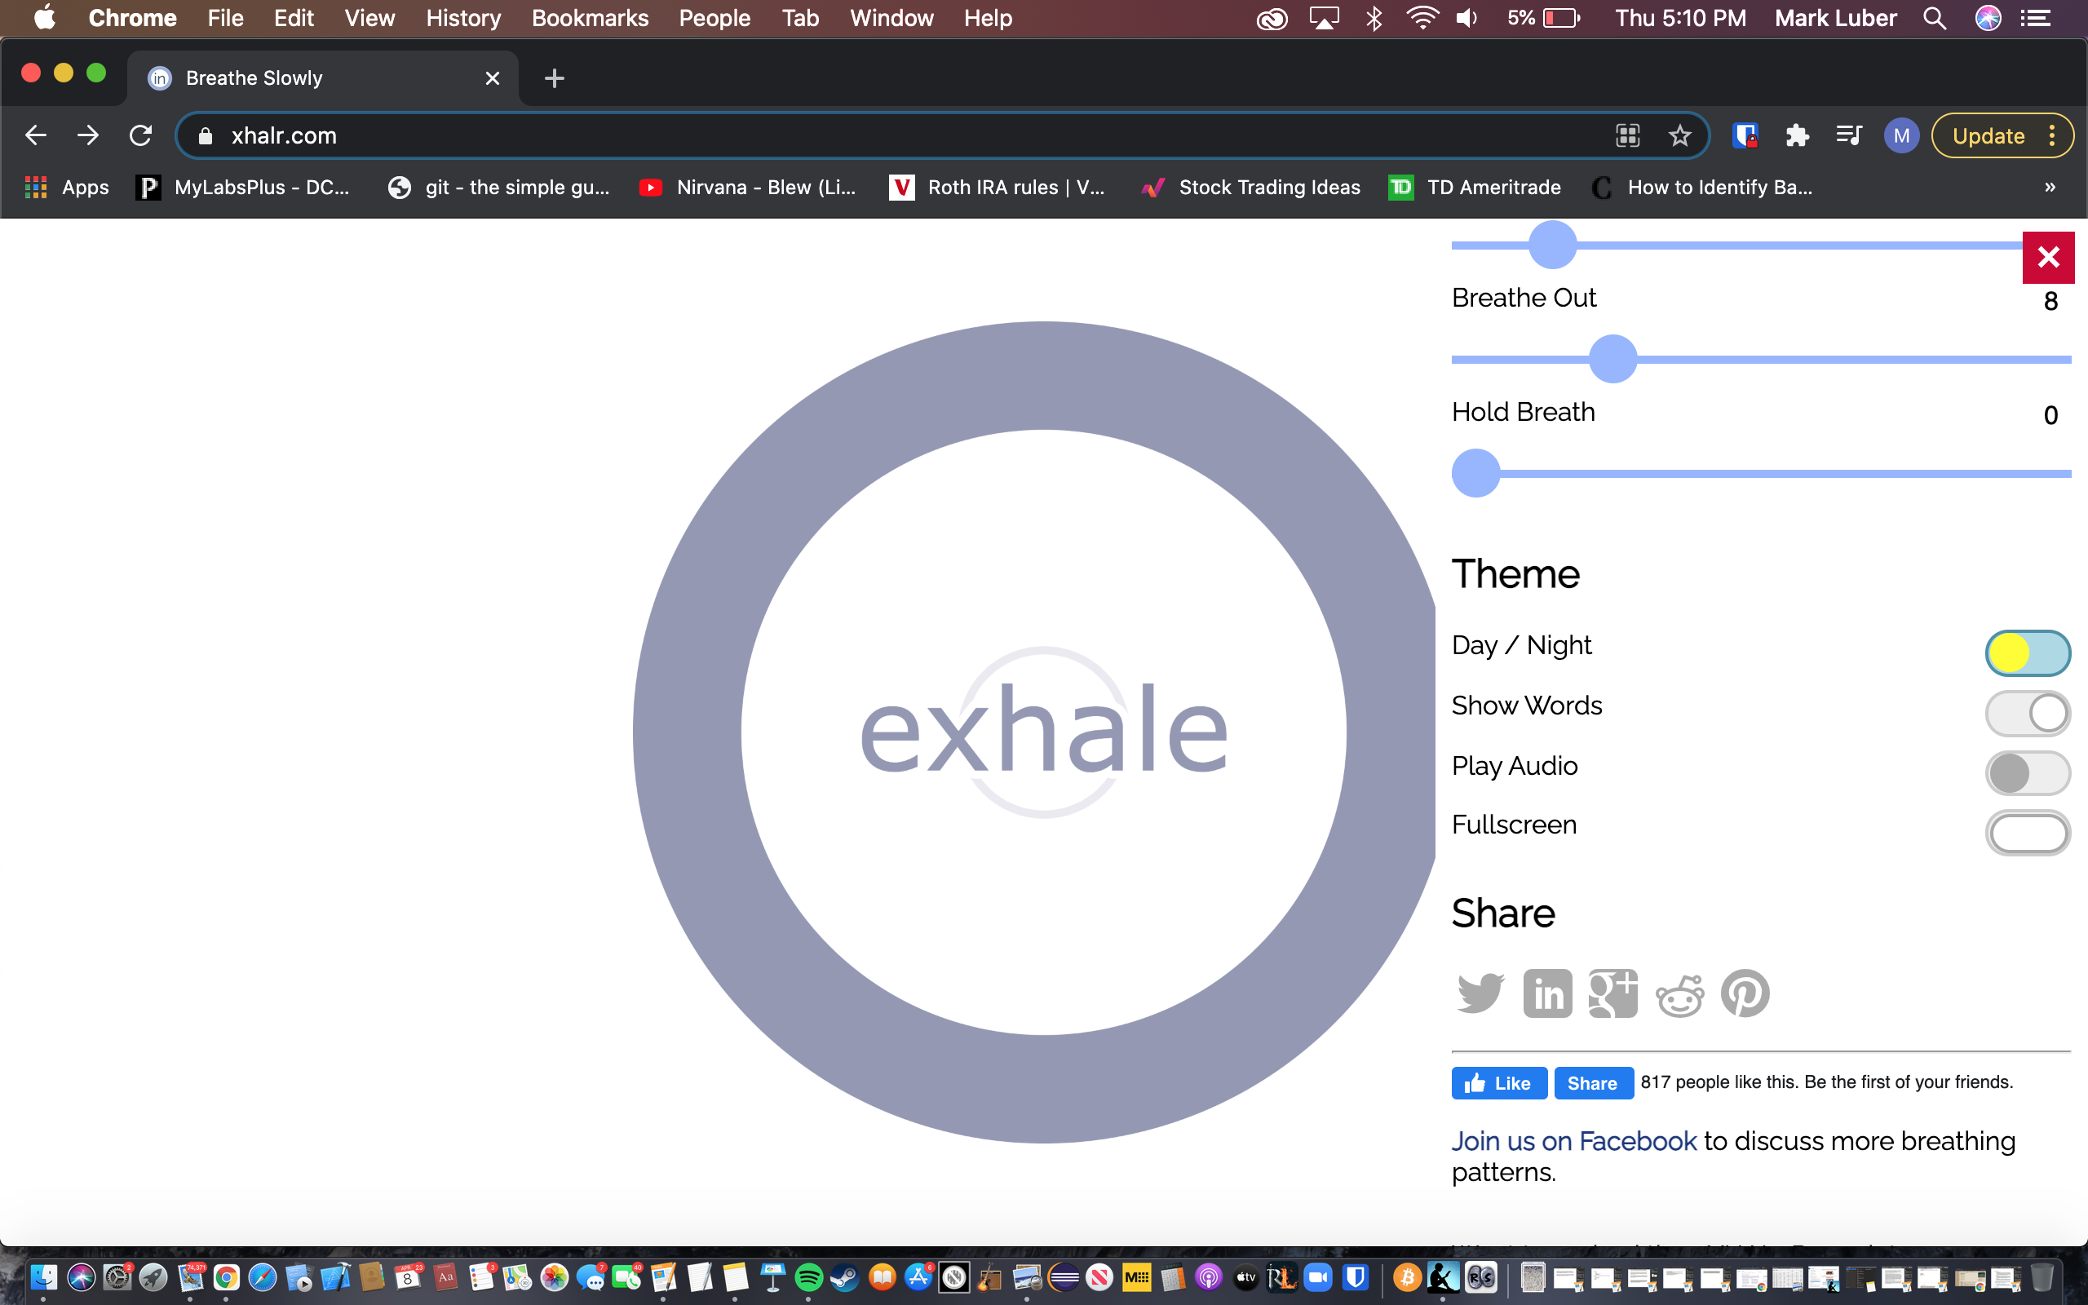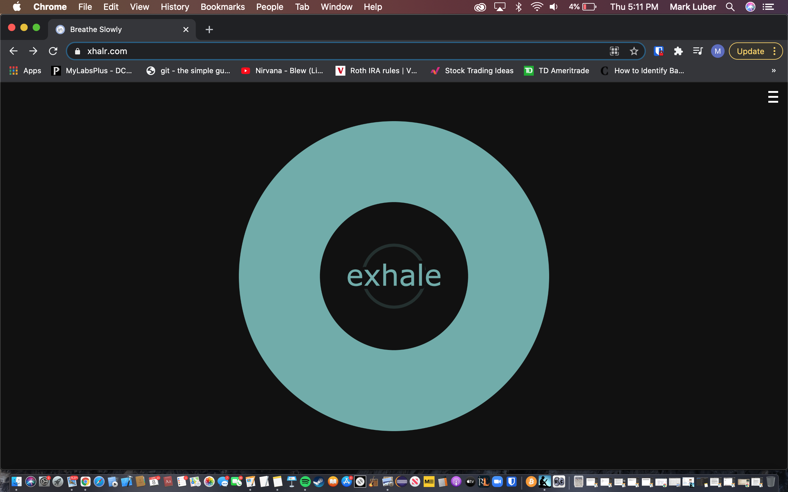

**Night Vs. Day mode**

**Animated circle to follow while practicing breathing techniques**

* 1. <https://quietkit.com/>
     + 1. The imagery and colors used are nothing fancy and are quite elementary, yet the overall theme is consistent. I don’t see a problem with simplistic graphics as long as the website is functional and the overall design, theme, and colors are consistent. The button and header colors are primarily red and blue, while most of the other content and text are black, grey, or white.

**Blue Audio buttons and drop-down audio player**

**4. Heuristic analysis**

1. Flexibility and efficiency of use

* + - 1. <https://asoftmurmur.com/>

Allows the user to customize and create custom mixes of soundscapes. Easy to use.

* + - 1. <https://xhalr.com/>

Allows for customization, personalization and is easy to use. Quite intuitive.

* + - 1. <https://quietkit.com/>

Does not allow for customization or personalization, but is incredibly straightforward and easy to use due to its simplicity.

2. Aesthetic and minimalist design

* + - 1. <https://asoftmurmur.com/>

Good minimalistic aesthetic. Most of the imagery is quite visually pleasing and the various icons are very comprehensible. I think the icons are designed extremely well because they easily convey an idea to the user without the use of text. The only problem I see is that the navbar buttons are not consistent throughout all pages of the website.

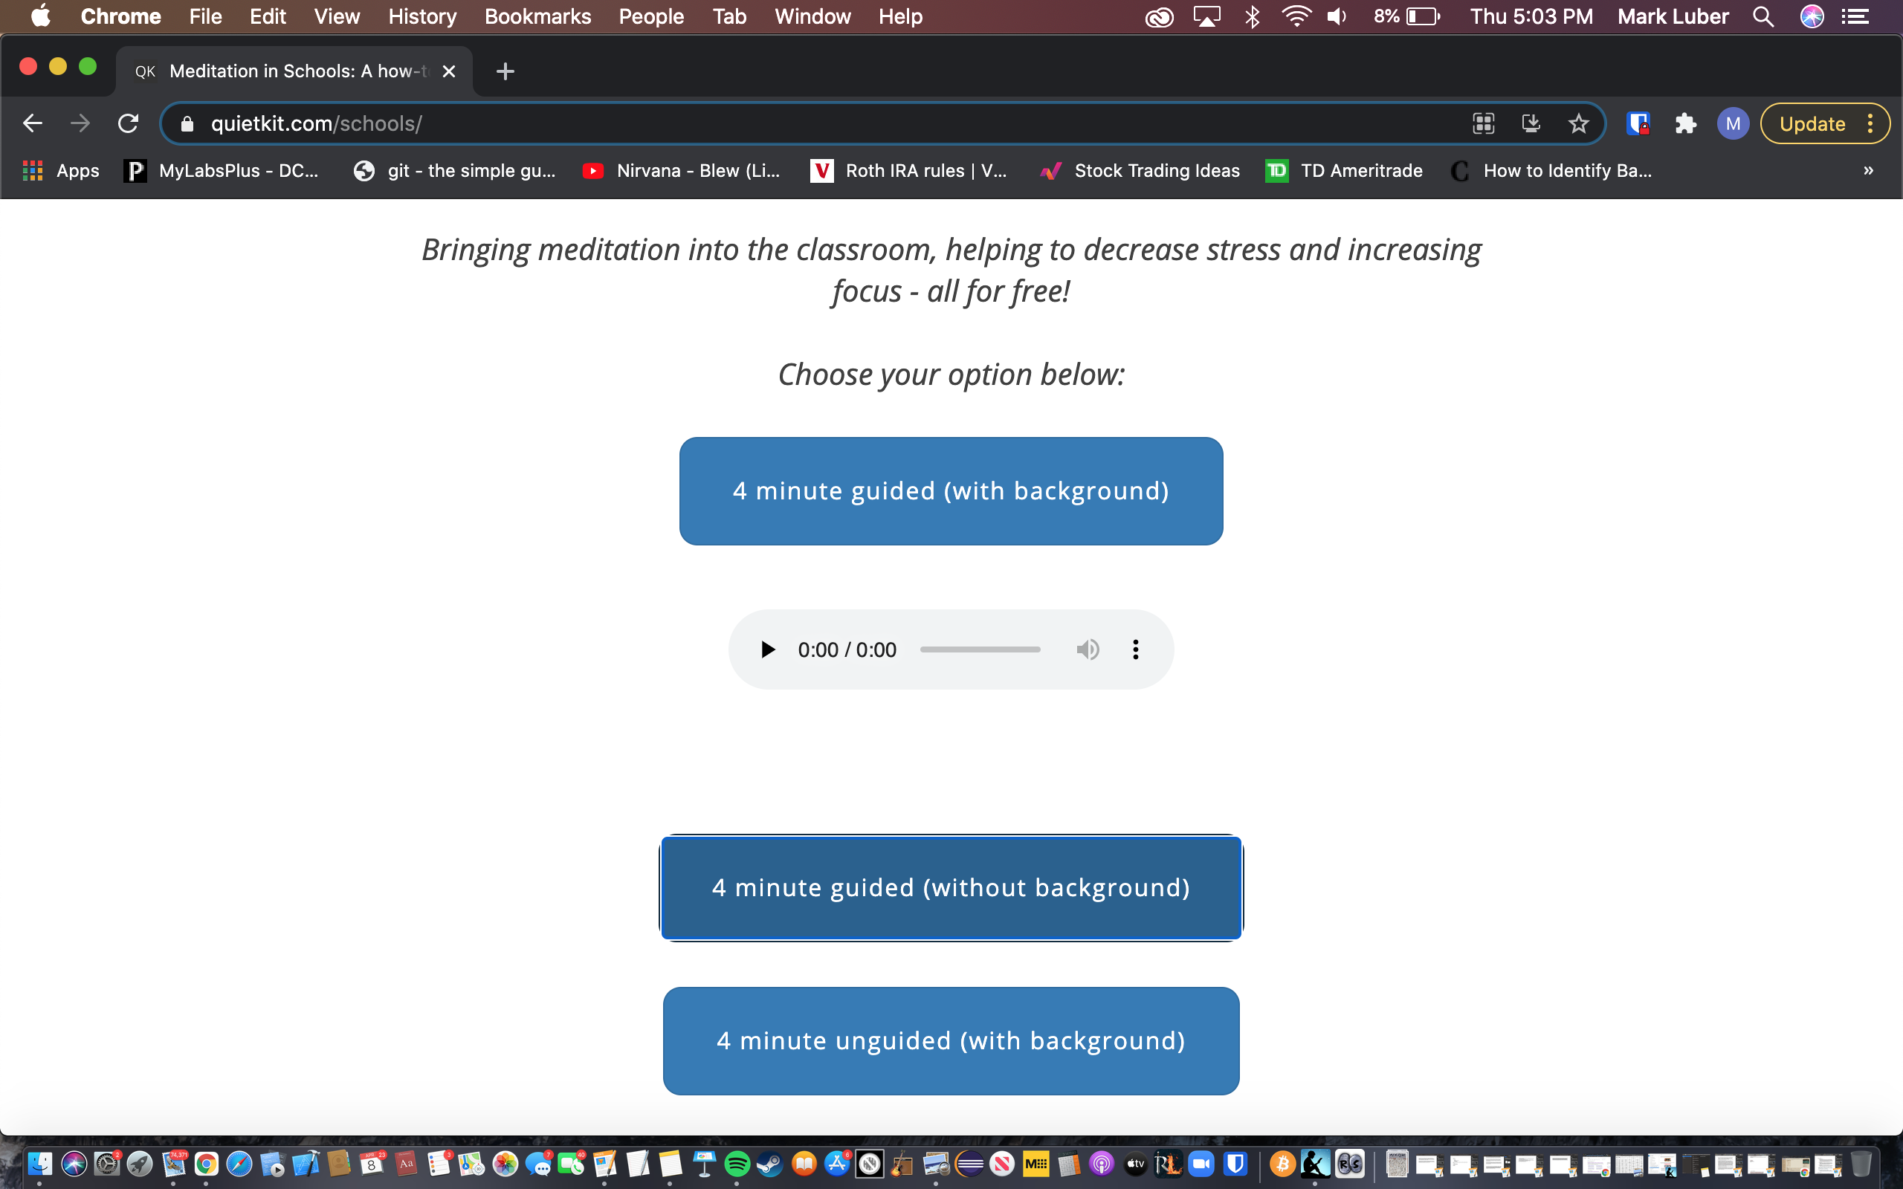

**Red social media buttons and blue section header**

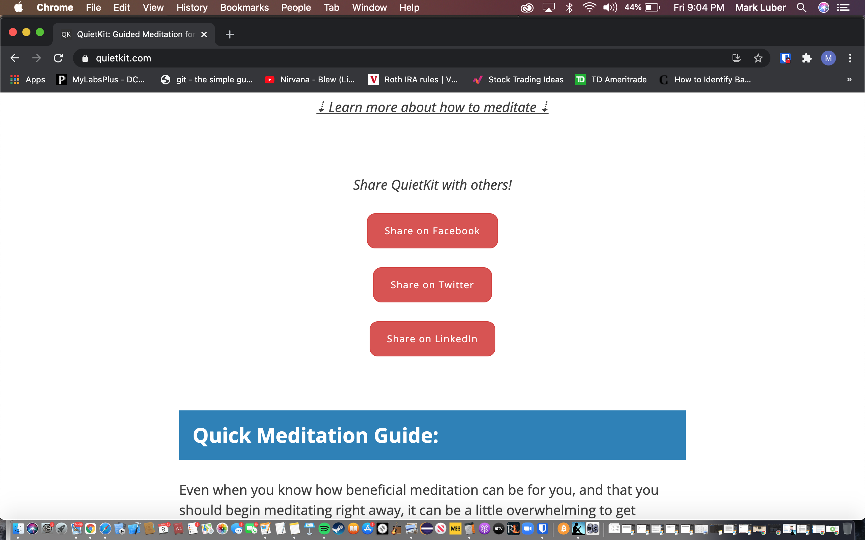

* + - 1. <https://xhalr.com/>

A fantastic representation of minimalist design. Consistent overall theme. Professional and clean design. Smooth animations. No fluff, the main focus is only functionality.

* + - 1. <https://quietkit.com/>

Not very visually interesting, but provides good documentation and information for the user to learn from. Simplistic design.

3. Help and documentation

* + - 1. <https://asoftmurmur.com/>

Does not need much extra explanation, but could be helpful for novice users. Documentation/help is provided by scrolling down to the bottom of the main homepage The documentation provided is short and concise and is presented in an elegant way.

* + - 1. <https://xhalr.com/>

Does not have documentation to teach the user how to use the website. This could be confusing for users without much prior knowledge on the subject. However, I think this website is very intuitive and most users could probably figure out how to use it without any instructions. Additionally, this website does provide external links to documentation regarding tips and strategies on to how to reduce anxiety and stress.

* + - 1. <https://quietkit.com/>

Provides a good amount of documentation. There is also a feature that allows the user to contact the website creator by clicking on the mail icon at the bottom of the webpage. Many external links are also available to the user that provide additional information and documentation on subjects related to meditation, reducing stress, and how meditation can help benefit students and schools.

**5. UI animations**

* + 1. <https://asoftmurmur.com/>
       - 1. Only a few animations are utilized on this website. An animation occurs when the user clicks on the play button. Sound icons turn from a clear to more opaque when the volume sider is increased. Furthermore, when the user clicks on the buttons called “timers”, “mixes”, or “share", the icons located below slide down to allow a drop down menu containing more information to open up into view. There are not many animations on this website and the animations are mainly just for looks.
    2. <https://xhalr.com/>
       - 1. The primary function of this website is based upon the user paying attention to the circle in the middle of the screen. The text in the center will indicate to the user when it's the correct time to take an inhale or exhale. The circle not only changes colors, but also changes sizes based on values set by the user. The user is supposed to follow the animation with their breath. As the circle expands the user is supposed to inhale, and as the circle shrinks the user is supposed to exhale. This is an amazingly simple yet extremely effective way of using animations to help users learn and practice new breathing techniques. Xhalr has the most visually appealing animations while at the same time leaves no room for fluff. The animation used is essential to the functionality of the website. Additionally, other content such as the main menu is animated.
    3. <https://quietkit.com/>
       - 1. This website is quite simplistic and does not really provide any animations with the exception of an animated visual similar to that of the one used on xhalr.com. The animation is simply a circle that expands and contracts at a specific speed. It is used to help users learn simple breathing techniques that are helpful in reducing stress, staying calm, and regaining mental clarity. The UI animations that are implemented on both [quietkit.com](http://quietkit.com) and [xhalr.com](http://xhalr.com) are valuable because they actually help the user learn something new. It is also worth nothing there are very slight animations used when the user clicks on the blue guided/unguided meditation buttons. When the desired meditation practice is selected a small audio player drops down below and pushes the buttons located below down further to create more room so everything fits correctly without being cramped.

**6. Score each website**

|  |  |  |  |
| --- | --- | --- | --- |
|  | <https://asoftmurmur.com/> | <https://www.xhalr.com/> | <https://quietkit.com/> |
| Content & Navigation | 6 | 7 | 9 |
| Aesthetics & style | 8 | 9 | 4 |
| Heuristic Analysis | 7 | 7 | 6 |
| UI Animation | 8 | 9 | 2 |
|  | **29** | **32** | **21** |